**Appium Automation Guide for Windows App**

**1.**install the Nodejs

**Link:** [**https://nodejs.org/en**](https://nodejs.org/en)

After Installed node check the version

**C:\Users\SSDADMIN>node -v**

**v20.9.0**

**C:\Users\SSDADMIN>npm -v**

**10.1.0**

2.install latest Appium GUI driver

**i.e** Appium-Server-GUI-windows-1.22.3-4.exe

If Appium is not listed, you need to install it globally using:

npm install -g appium

3.install the Appium inspector or Windows SDK to inspect element in web application

**i.e** Appium-Inspector-windows-2023.11.1.exe

link about winapp driver [GitHub - microsoft/WinAppDriver: Windows Application Driver](https://github.com/microsoft/WinAppDriver)

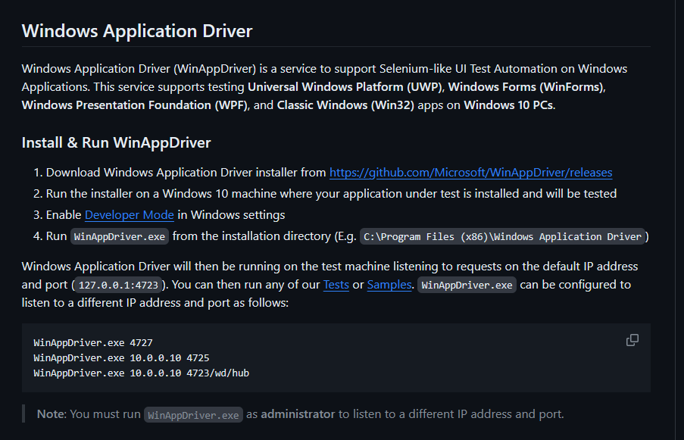

4.Install the windows application driver

**i.e** WindowsApplicationDriver-1.2.99-win-x86.exe

**Install below library on your Pycharm community tool**

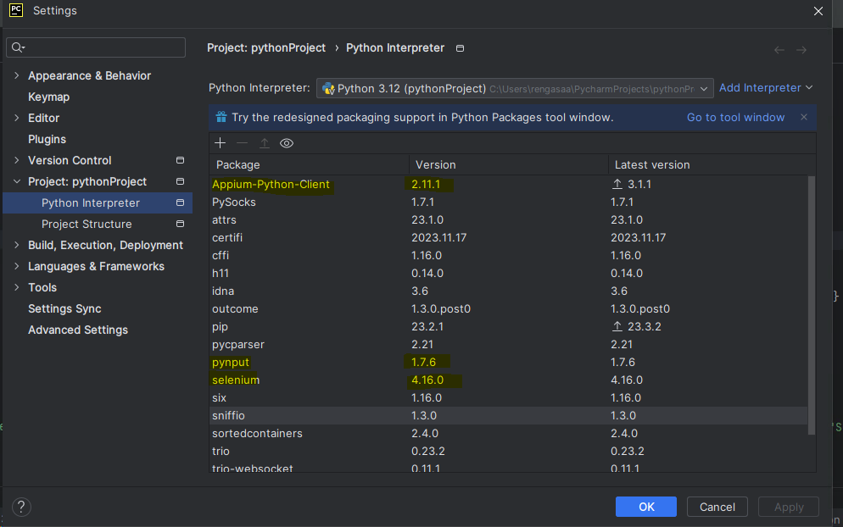

**Script Screenshot:**

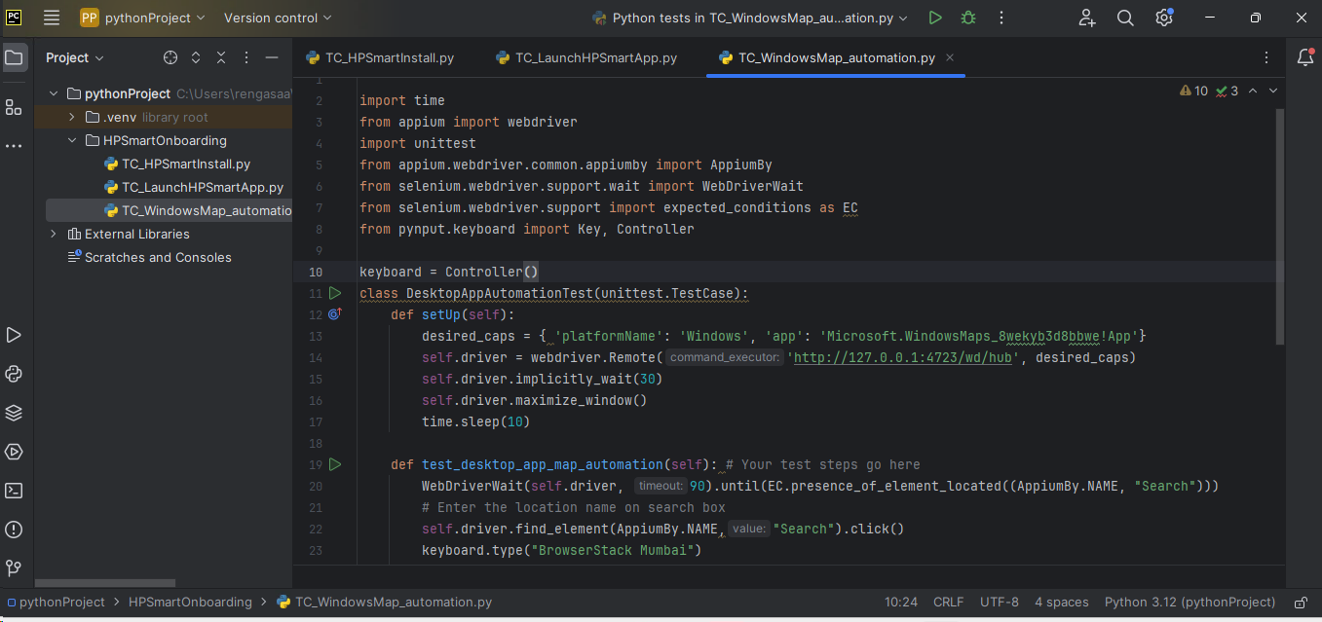

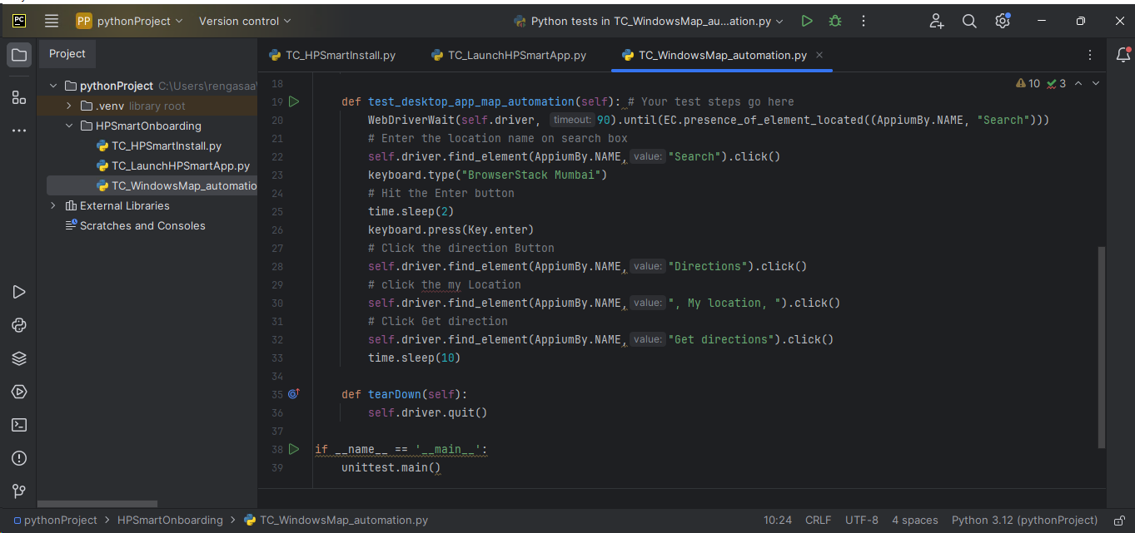

**Example of Getting the APPID from Installed Windows App**

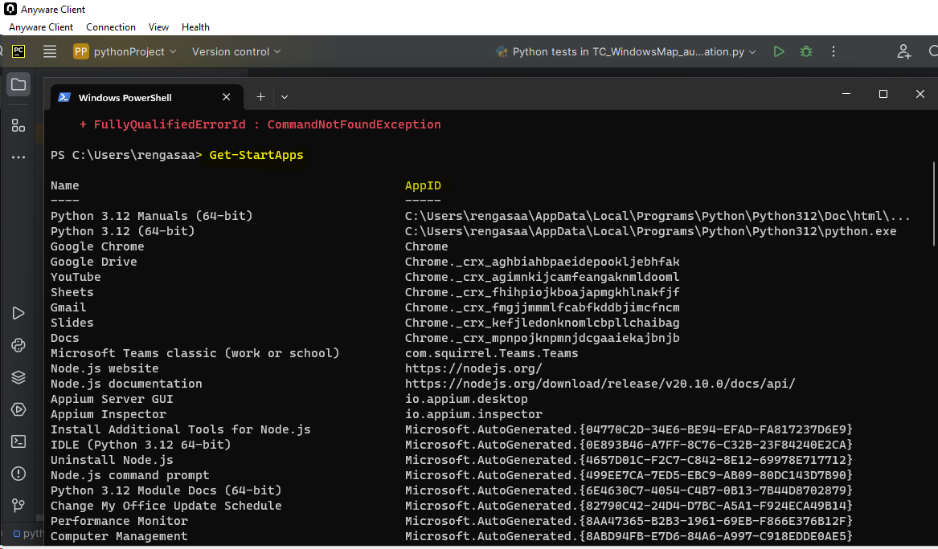

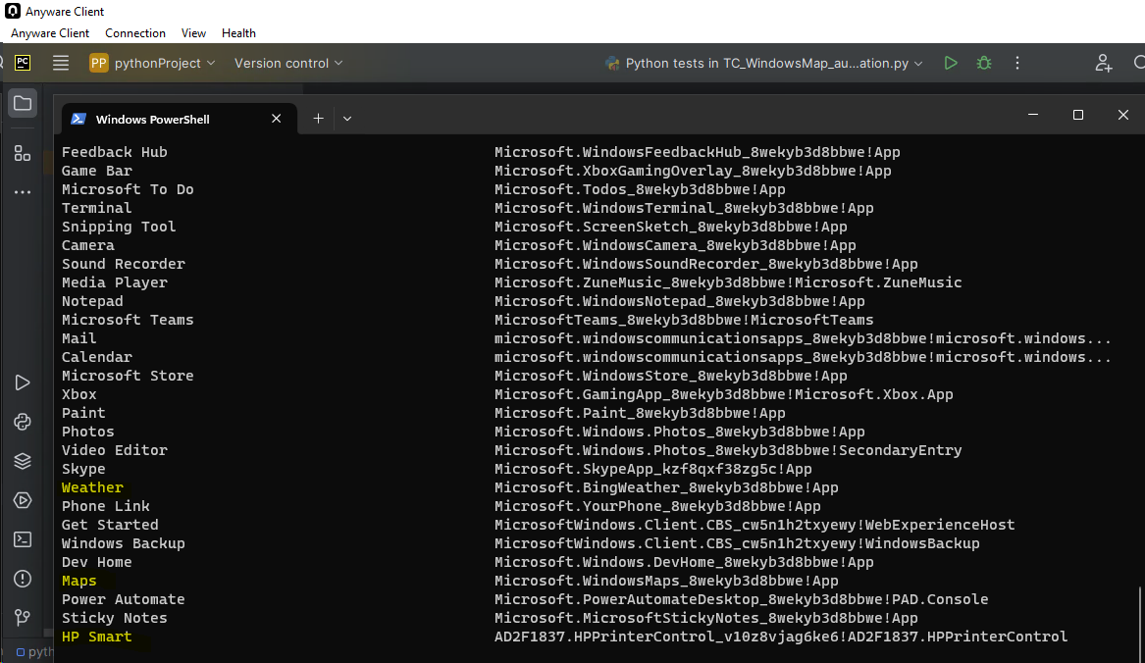

**Additional information**

appium driver install --source=npm appium-windows-driver

Create a session on Appium Inspector

**Session Logs:**

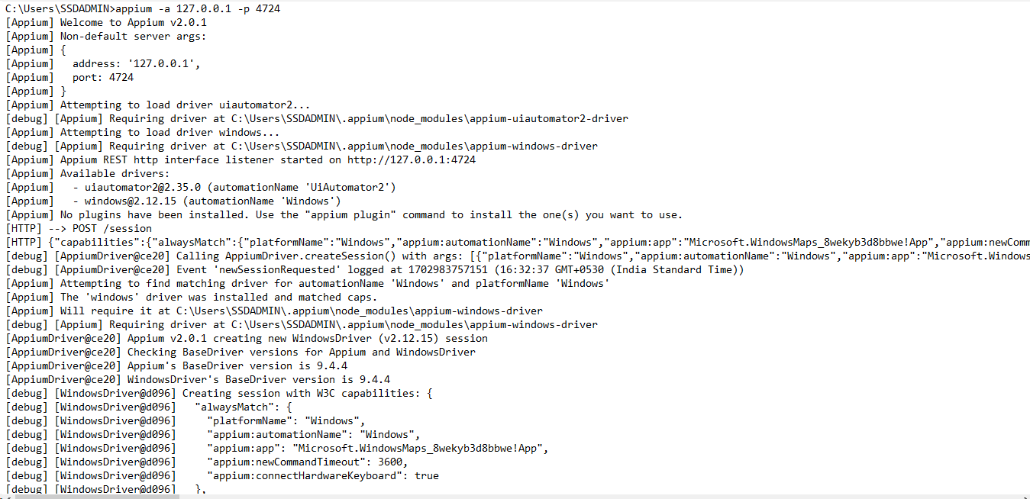

**Inspecting element on Windows Map using Appium Inspector**

Automation ID:

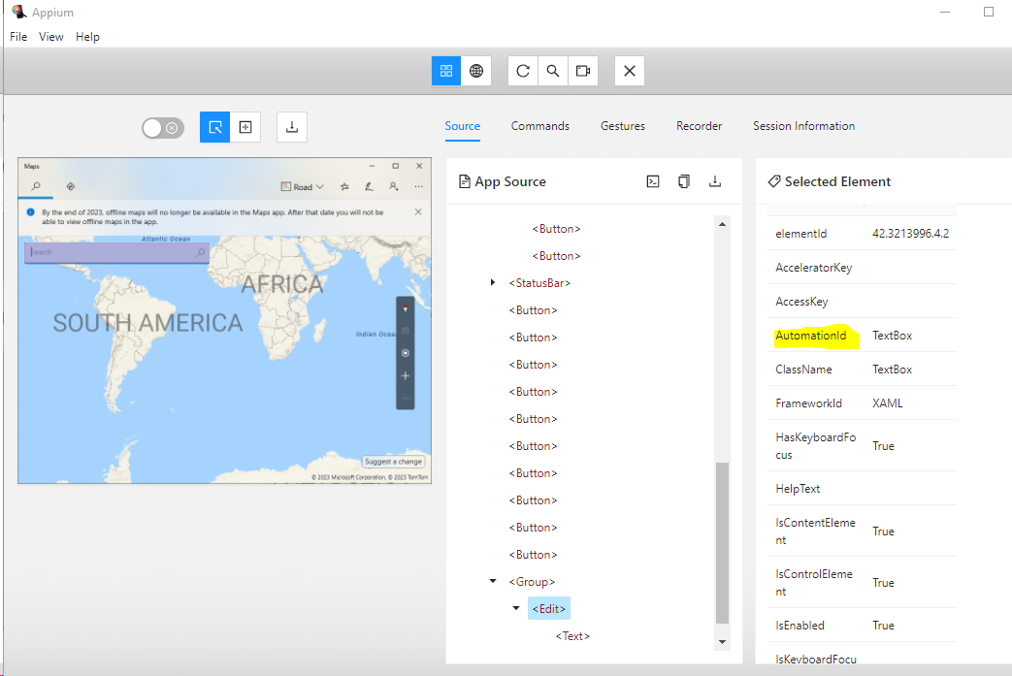

Name Property

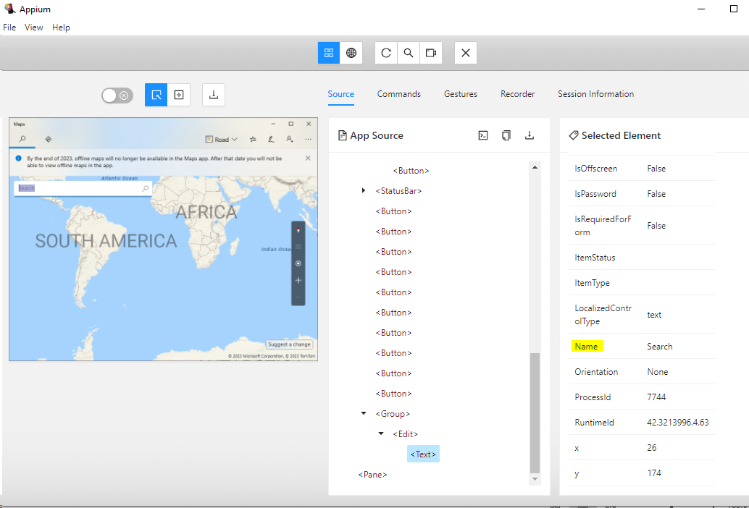

**Click the Refresh button after Enter the Location on Maps**

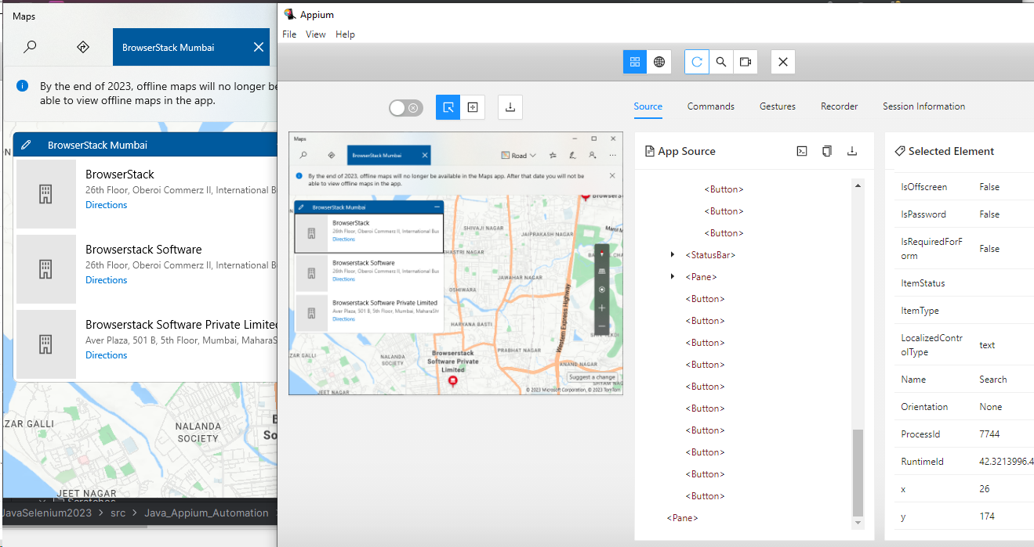

**Click the Direction**

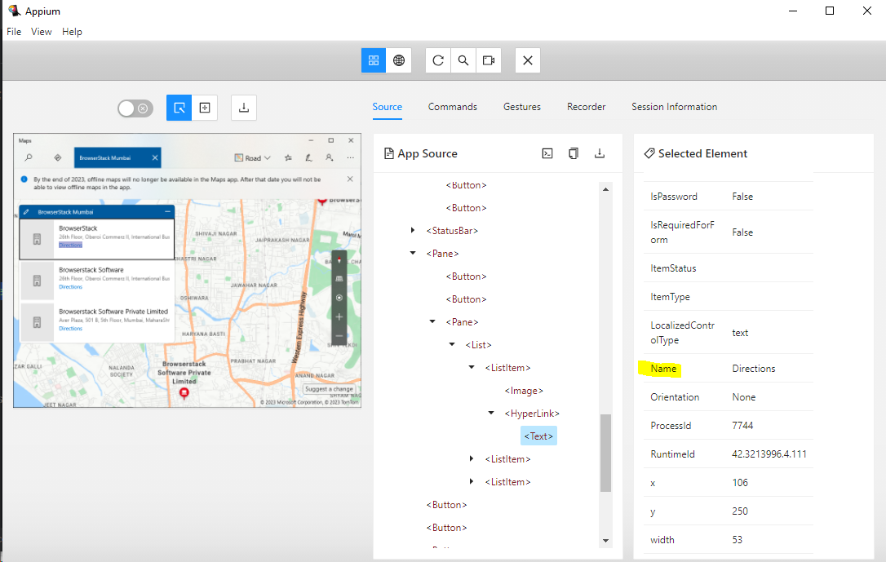

Click the **“My location”** and click the **“Get directions”**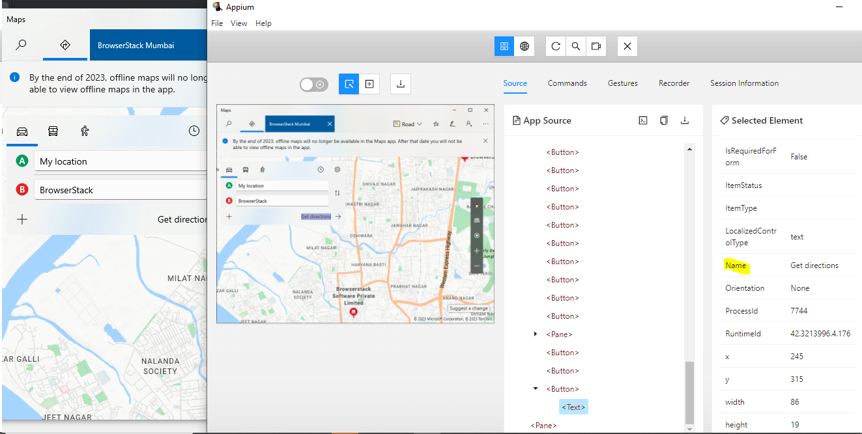

**Below command is used to get the PID instance**

[netstat -a -n -o | find "4723"](https://stackoverflow.com/questions/15952663/find-the-pid-of-a-process-that-uses-a-port-on-windows)

